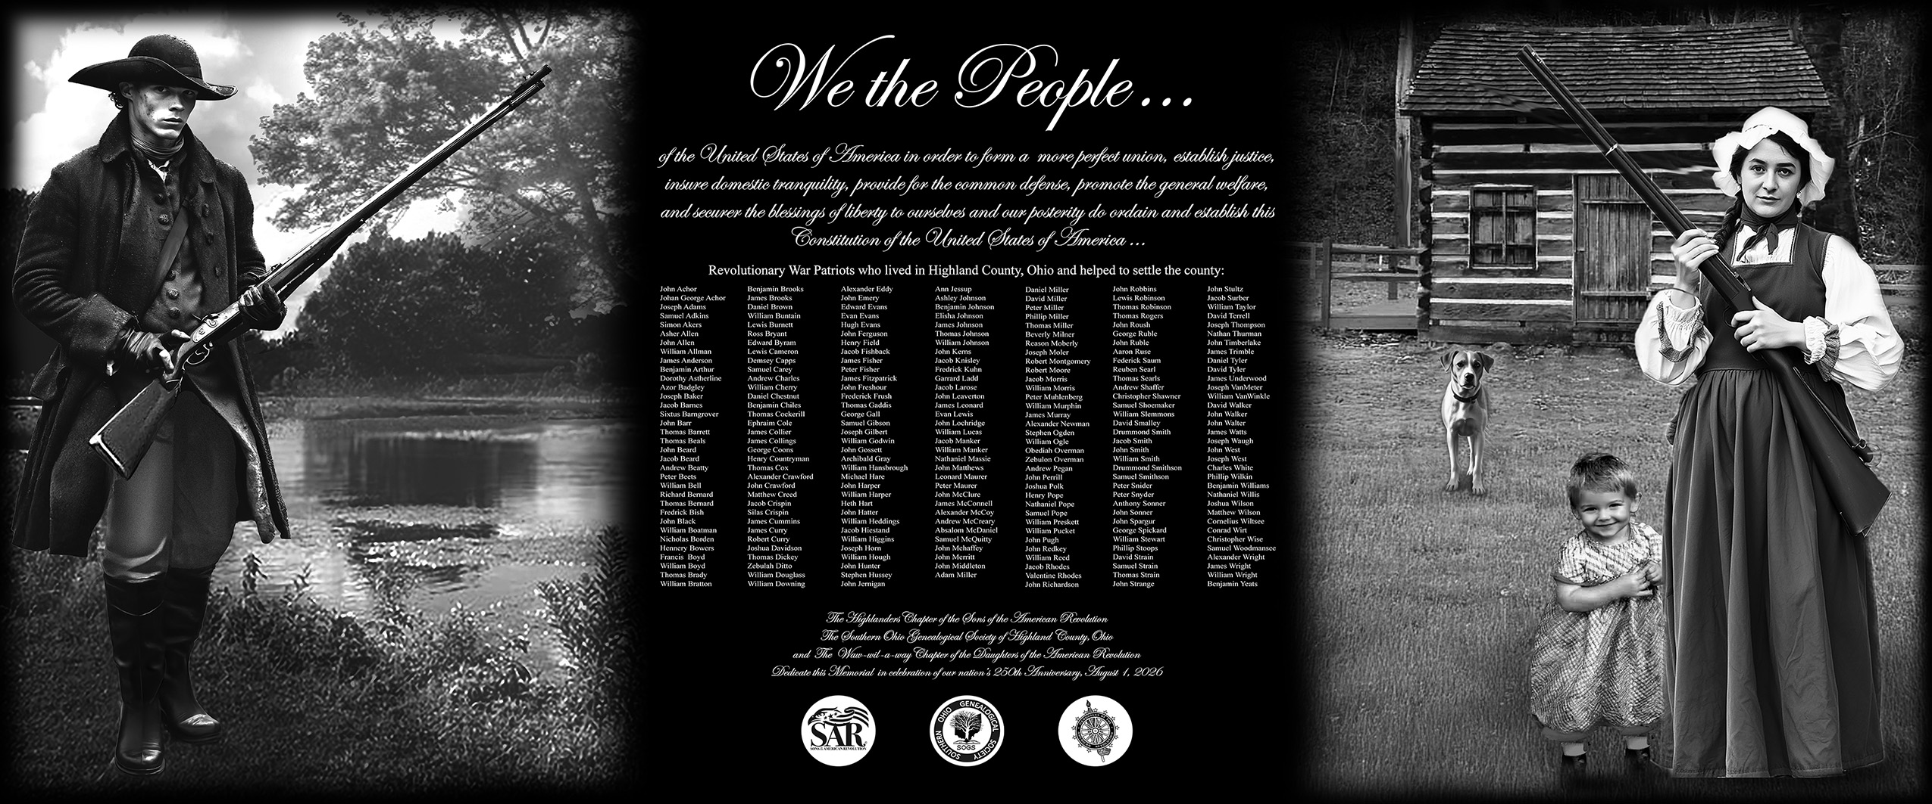

Highland County Revolutionary War Memorial 250th Ceremony
July 18, 2026 6:00 PM

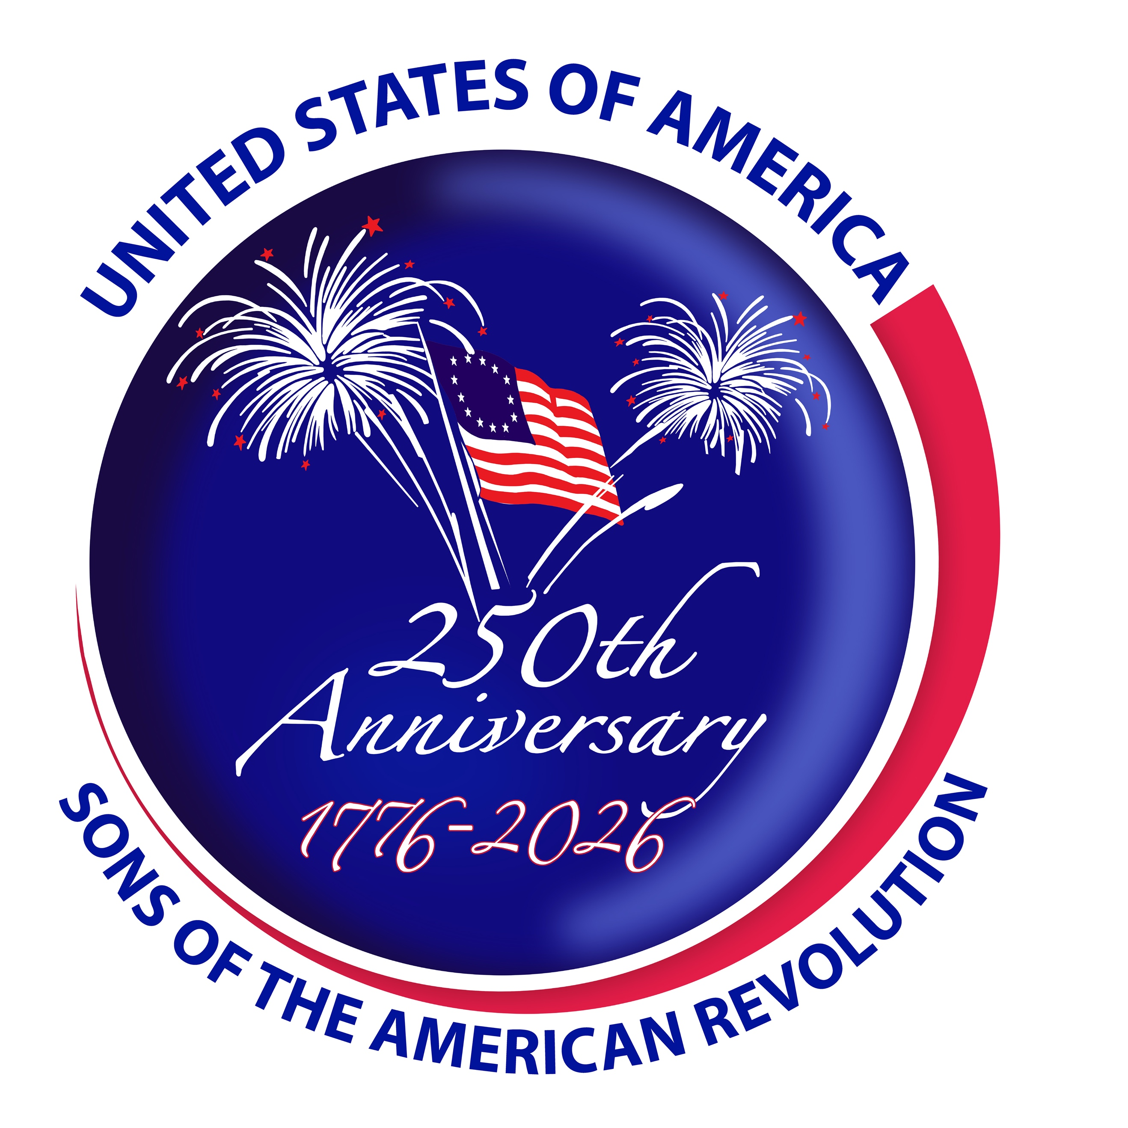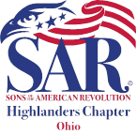
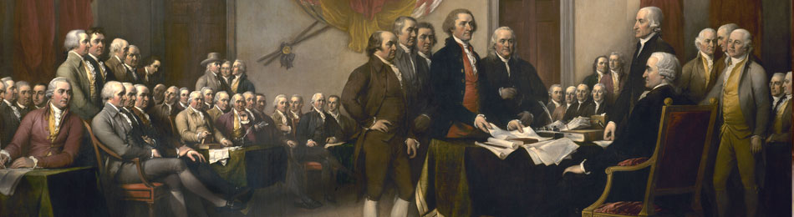
Highland County Revolutionary War Memorial Ceremony

Emcee’s Command, Gary Duffield
Presentation of Colors: Highland County Veterans Honor Guard, Commanded by Rudy Diskette.
Pledge of Allegiance, Jane Stower
National Anthem by: Jack Bredenfoerder
Invocation by:
DAR Pledge / American Creed by Regent Cara Pfeifer
SAR Pledge by SAR Members: Gary Duffield
Welcome of Descendants of Patriots:
Unveiling and dedication of the Monument
Dedication by Emcee ? DAR
Introduction and Welcome of Guests Speakers: By Emcee
How many politicians
~ Honor Guard 21 Gun Salute:
~ Taps by
~ DAR / SAR Recessional led by:
~ Retiring the Flags in place by Highland County Veterans Honor Guard
~ Benediction by:

Highland County Revolutionary War Memorial 250th Ceremony

6:00 PM on July 18, 2026 at Hillsboro, Ohio
Highland County Courthouse 119 Foraker Place, Hillsboro, OH 45133. [ GPS 39.202526 -83.611974].

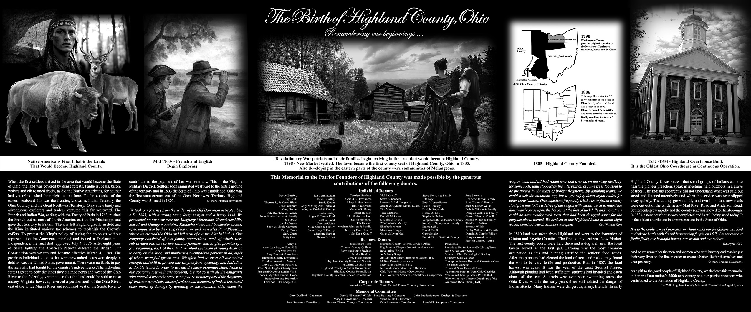

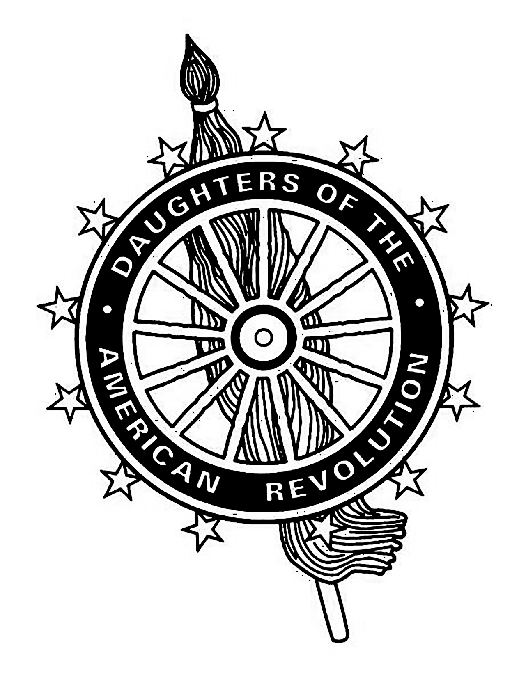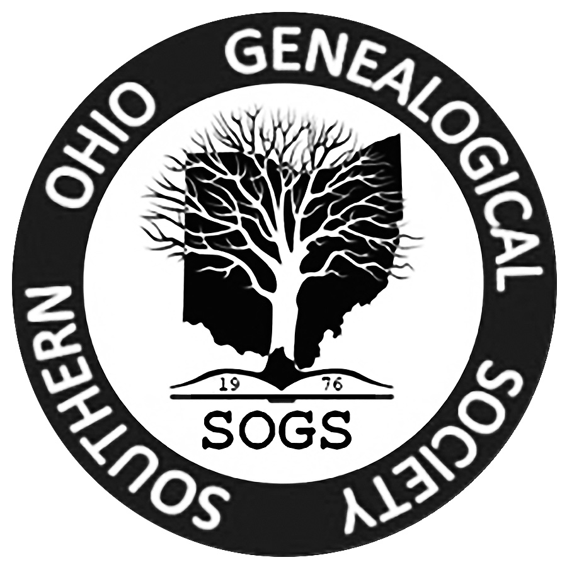

Dedication:
We, the members of the Highlanders Chapter of the Sons of the American Revolution and Waw-wil-A-way Chapter of the Daughters of the American Revolution dedicate this Memorial to the glory of God and in the recognition and memory of these honorable Patriot of the American Revolution.
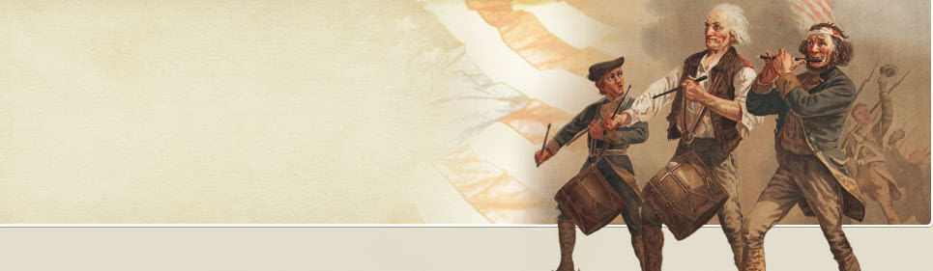
DAR American Creed:
"I believe in the United States of America as a government of the people, by the people, for the people, whose powers are derived from the consent of the governed; a democracy in a Republic; a sovereign Nation of many sovereign States; a perfect Union, one and inseparable; established upon those principles of freedom, equality, justice, and humanity for which American patriots sacrificed their lives and fortunes. I therefore believe it is my duty to my country to love it; to support its Constitution; to obey its laws; to respect its flag; and to defend it against all enemies.
Pledge to the SAR:
We the descendants of the heroes of the American Revolution who, by their sacrifices, established the United States of America, reaffirm our faith in the principles of liberty and our Constitutional Republic, and solemnly pledge ourselves to defend them against every foe.
SAR Recessional: Until we meet again, let us remember our obligations to our forefathers, who gave us our Constitution, the Bill of Rights, an independent Supreme Court, and a Nation of Free Men.
The service today is provided for by the Waw-wil-a-way Chapter of the Daughters of the American Revolution, the Highlanders Chapter of the Sons of the American Revolution of the Ohio Society of DAR & SAR , Southern Ohio Genealogical Society and Highland County Veterans Honor Guard
Dignitary Attendees:
OHSSAR President Douglas Pettit
CCSAR President
Past OHSAR President
Past Cincinnati SAR Chapter Pres
Highland Chapter, President Gary Duffield
DAR – Wal-wil-a-way Hillsboro Chapter Regent Cara Pfeifer
DAR - ??? Chapter Regent
DAR -Clough Valley Chapter Regent Debbie Niehaus,

Descendants:

Citizens attending “Highland County Revolutionary War Memorial” Event

Music: , TAPS

Photos:

