America 250: Heritage Tree Dedication with Martha Washington & Revolutionary War Soldier
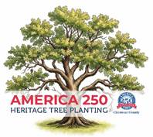
BATAVIA, OHIO (Oct. 8, 2025) – A revolutionary-style celebration! Living historians portraying Martha Washington and a Revolutionary War soldier are joining officials today at Sycamore Park in Batavia to dedicate Clermont County's America 250 Heritage Tree.
The ceremony, which was free and open to the public, is part of a series of ongoing events this year and next in Clermont County that commemorate America's semiquincentennial. The dedication of the swamp oak took place at Sycamore Park's recently completed sun deck by the East Fork of the Little Miami River. Tours of the deck and nearby swinging bridge at noon. The tree dedication was at 12:30 p.m.
Angela Carpenter with the Clough Valley chapter of the Daughters of the American Revolution shared anecdotes about President and Gen. George Washington. Michael Gunn with the Cincinnati Chapter of the Sons of the American Revolution talked about the origins of the Liberty Tree and how its destruction feed the Revolution and the patriotic effect in early 1774.
Clermont County and east within the Military District, in Ohio and his ancestor's life as a patriot and Dragoon in the 3rd Continental Light Dragoons who also served as George Washington & Martha’s Guard..
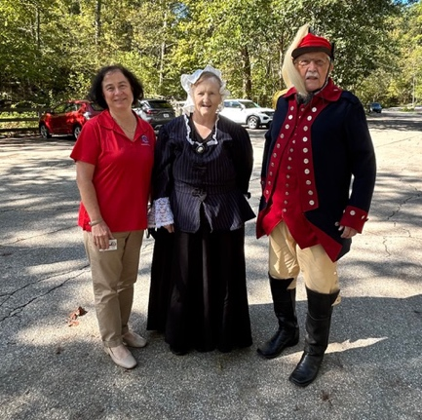
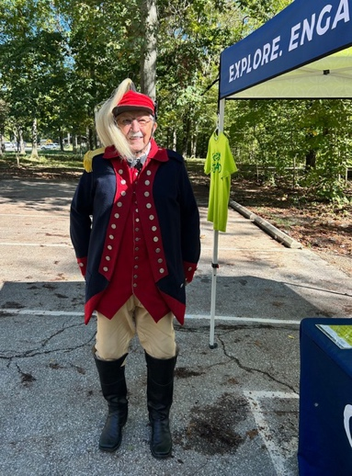
Clermont County commissioners David Painter, Claire Corcoran and Bonnie Batchler attended the ceremony along with officials with the Clermont Park District, Clermont County Chamber of Commerce and Clermont County Convention & Visitors Bureau.
Ursula Miller, Angela Carpenter & Michael Gunn
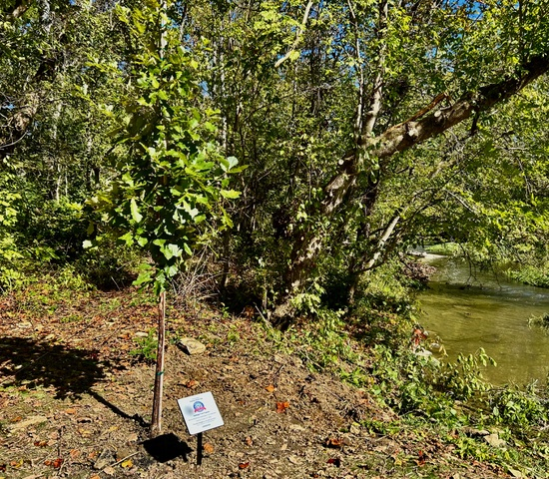
Michael Gunn, CCSAR as Washington's Guard
Clermont County Heritage Tree Oct. 2025

