Go to www.sar.org and using your “National” and “State” member numbers, log into the www.sar.org protected site


Click on SAR University (second row, middle selection)
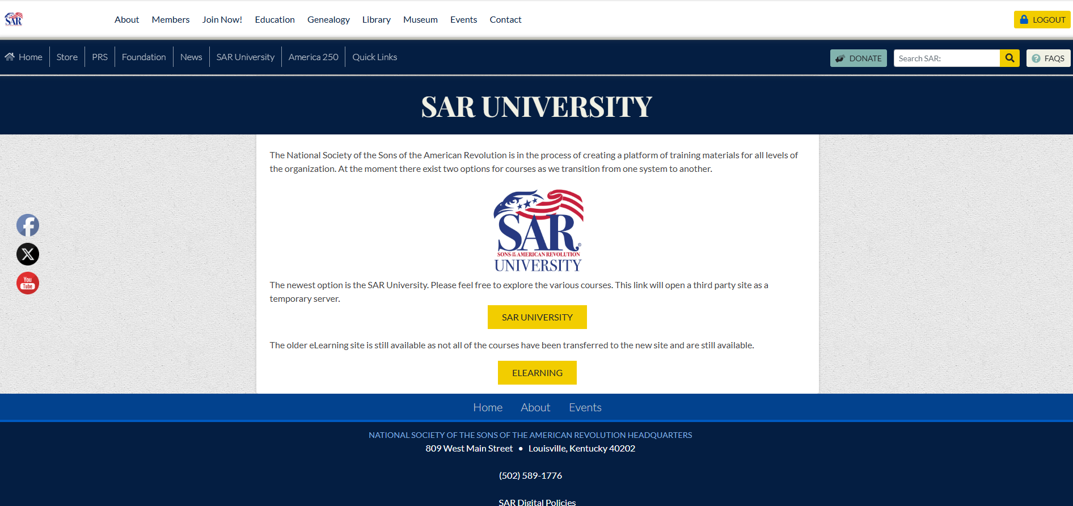
Click on SAR University button in middle of the screen
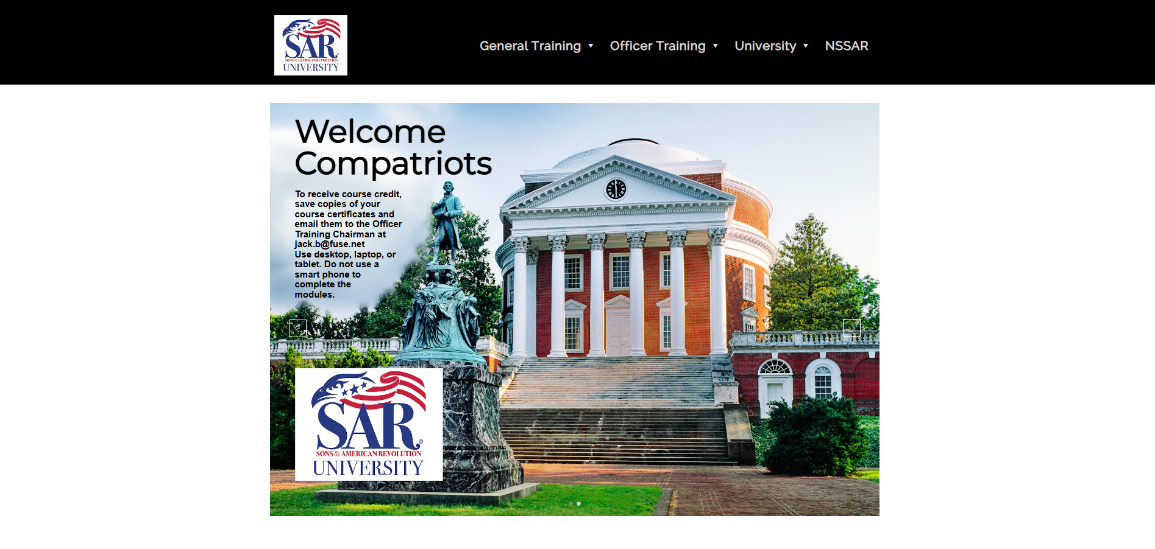
Click on “General Training” on top row (note the other options for you to explore)
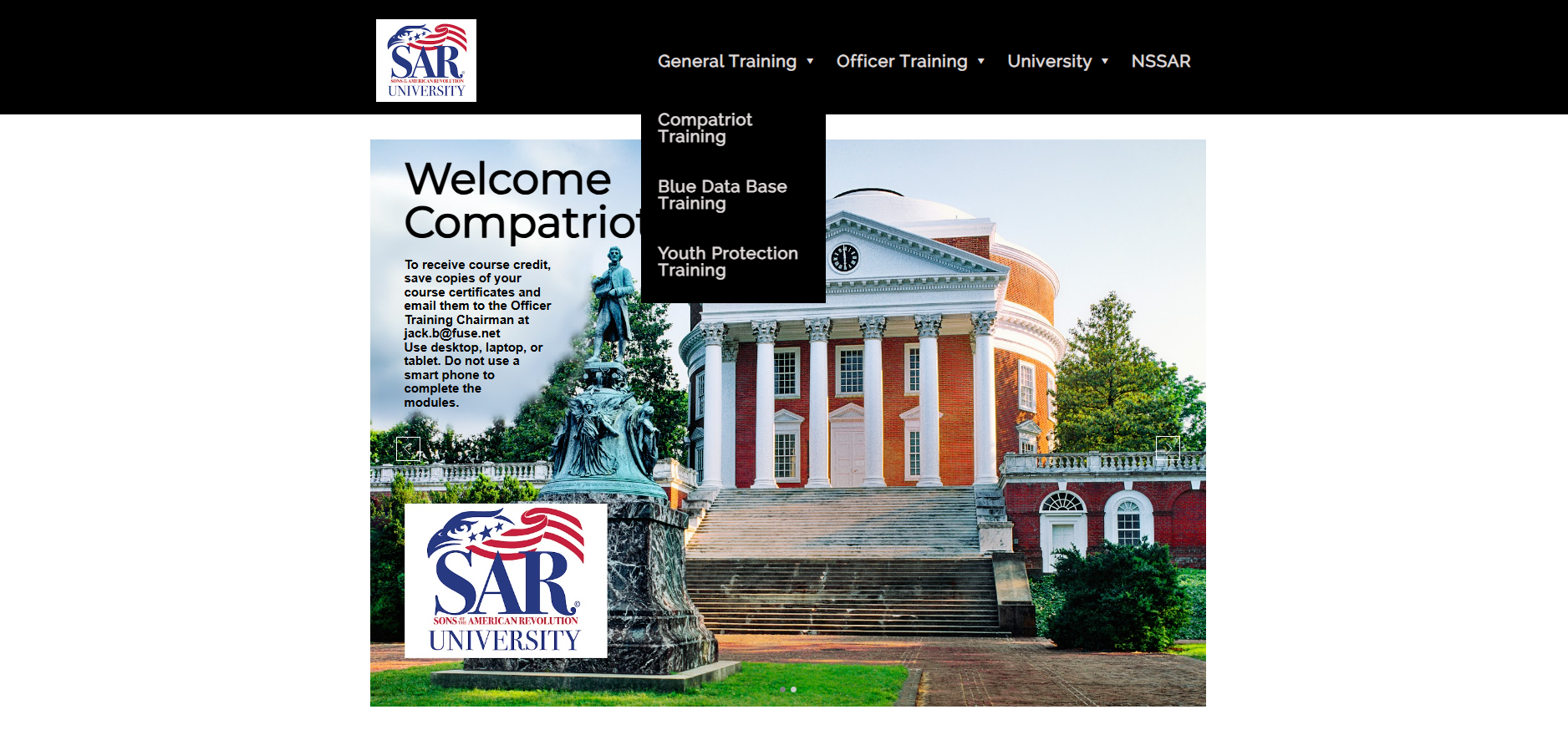
Click on Compatriot Training (note also Youth Protection Training) as well as “Officer Training” top row
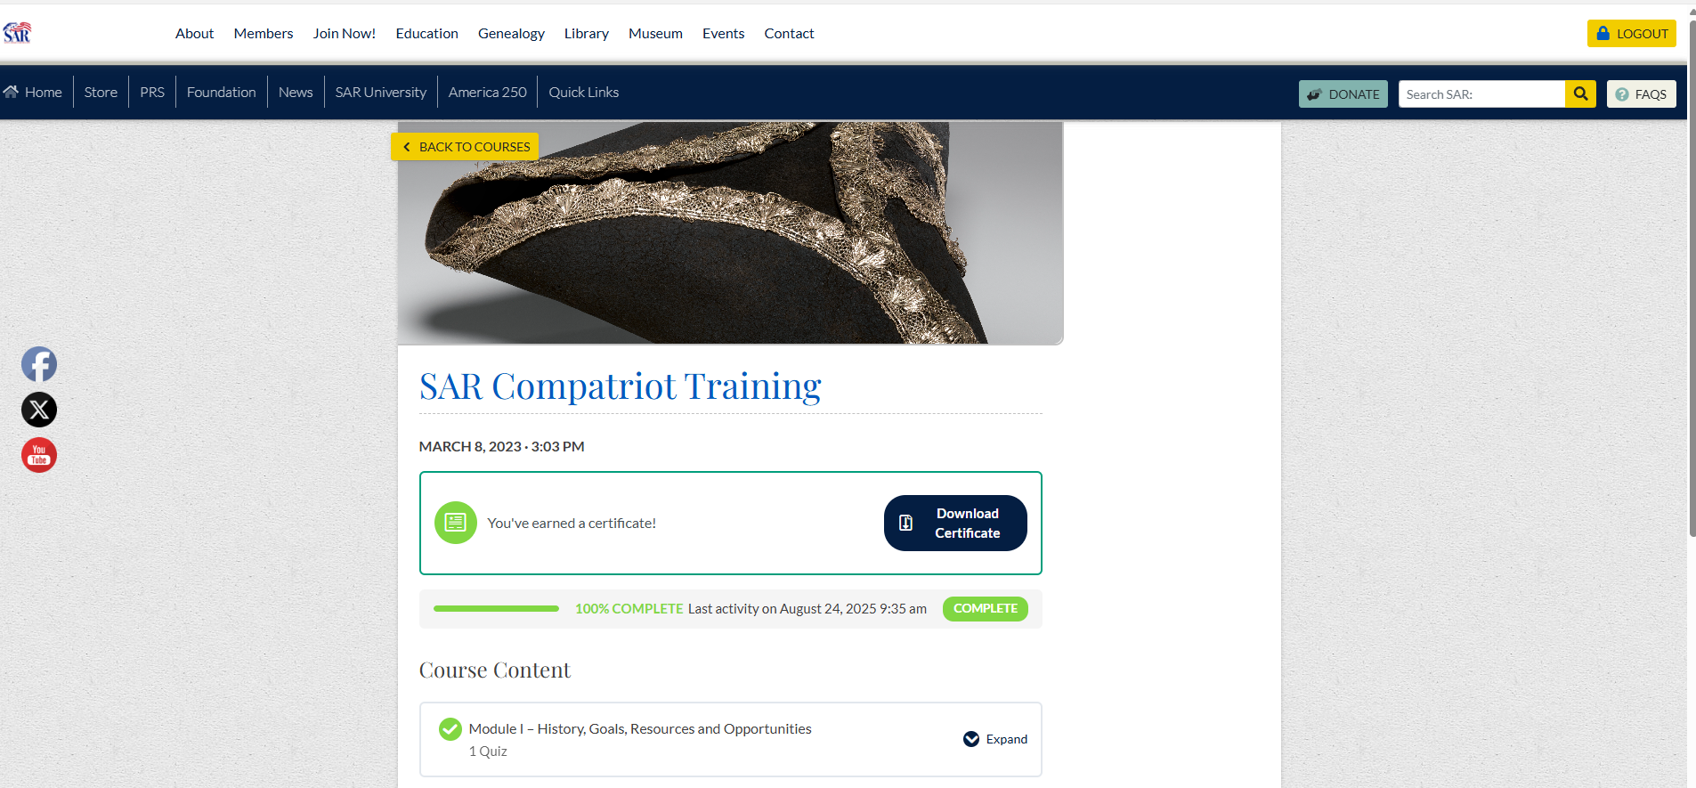
Start your Training Module – note I completed this training so it is marked as complete. If you are starting, this module would be open for you to start. Upon completion of the course modules, you will be asked to complete a short quiz to confirm your successful understanding. When successful, you will receive a notice of completion and be able to print/download a Certificate.

