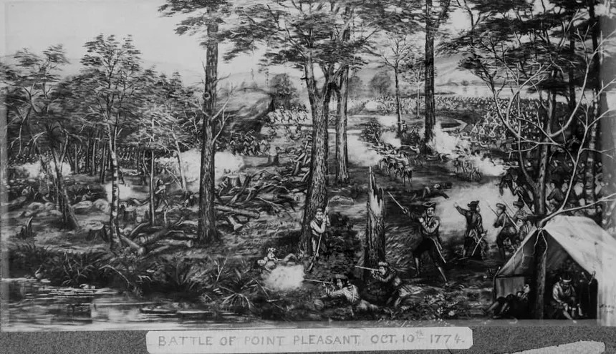

The Point Pleasant Chapter of the WVSSAR cordially invites you to the 251st anniversary commemoration of the Battle of Point Pleasant on October 3rd, 4th and 5th, 2025.

Activities:

Friday, October 3rd, 2025 - Education day
Beginning at 8:00am, demonstrations at Tu Endi Wei State Park of colonial life and Revolutionary War regimental and militia activities for various school groups and visitors.
Dusk - 10:00 pm - Lantern tour through Tu Endi Wei State Park of various stations and re-enactors at dusk.

Saturday, October 4th, 2025
10:30 am - Muster of all SAR Color Guard personnel at 10th and Main Street, Point Pleasant, WV.

11:00 am - The SAR Color Guard will lead the Battle Days Parade beginning at 10th and Main Street and ending at the Tu Endi Wei monument for group pictures.

06:00 pm - The Colonial Governor’s Reception will begin at the Main Street Baptist Church, 11th and Main. St., Point Pleasant, WV. (Pre-registration required for all SAR attendees and guests).

08:00 pm - The Colonial Governor’s Ball will begin at the Main Street Baptist Church, 11th and Main St.., Point Pleasant, WV (Open to all.) 18th century attire encouraged but not required. No charge, but registration encouraged.

________________________________________________________________________

Sunday, October 5th, 2025
10:00 am - Colonial church service at Tu Endi Wei State Park.

11:30 am - Brunch will be offered at Randolph Terrace, 123 Main Street,
Point Pleasant, WV. (Pre-registration required)
*immediately adjacent to Tu Endi Wei State park for convenient parking.

1:00 pm - Commemoration service and wreath presentation honoring the fallen at the Battle of Point Pleasant. (Pre-registration required).
________________________________________________________________________

Area lodging:

Hampton Inn
(740) 446 8000
444 State Route 7 South
Gallipolis, Ohio 45631

Super 8 Motel
(740) 446 8080
321 Upper River Road
Gallipolis, Ohio 45631

4 Seasons Inn
151 Upper River Rd.
Gallipolis, Ohio 45631

Registration

Colonial Governor’s reception ($35.00 per person) # attendees ______

Colonial Governor’s Ball (Free) # attendees _________

Battle Day’s Brunch ($25.00 per person) #attendees________

Name of attendee and guests:

_____________________________________________________________________________________

_____________________________________________________________________________________

**Fees for the Colonial Governor’s reception and Battle Day’s Brunch will be collected at the door (cash or check only). Please indicate the name and number of attendees above and return this form so that we can arrange for sufficient quantities of food and beverage with the caterer.**

_____________________________________________________________________________________

Battle Days Commemoration and Wreath Honors Registration

Name: _________________________________

Guest:__________________________________

Address:________________________________

City:____________________________________ State:_____ Zip:__________

Email:___________________________________

Battle Days Parade _____yes _____no _______________State or Chapter Colors

Color Guard Yes______ No______

Musket Salute Yes______ No________ (certification required)

Wreath placement Ceremony Yes_______*

Name of person presenting the wreath: ___________________________________

Title or Office you hold: ___________________________________________________

___________________________________________________________________________

Name of organization being represented: _________________________________

___________________________________________________________________________
*Pre-registration is mandatory if you wish to be placed in the proper order of precedence. If you do not pre-register by September 15, 2025 you will be placed in the order received at the end of those who pre-register.
Return this Form to:
Point Pleasant Chapter, WVSSAR
P.O. Box 511, Point Pleasant, WV 25550

