Cincinnati SAR Presented a JROTC Medal & Certificate at Diamond Oaks High School

On Tuesday, May 7, 2024 at 6 PM Cincinnati Chapter of the Sons of the American Revolution was represented by Michael Gunn at the Diamond Oaks High School for their Army JROTC Awards Night. He was joined by 26 other presenters including Regent Monica Mohlenkamp, Kathy Schmid & Sharon Weber from Cincinnati DAR.

Dr. Gunn Presented Cadet Sergeant Christian Hammond with the SAR Bronze JROTC Medal, Certificate of Excellence and a laser etched Cherrywood Challenge Coin. Sgt Hammond was one of 34 recipients from the Diamond Oaks Program. Many other cadets were recognized for their mental and physical accomplishments in this fine program staffed by James Michael Moyer, CW2, US Army (Ret), Senior Army Instructor.
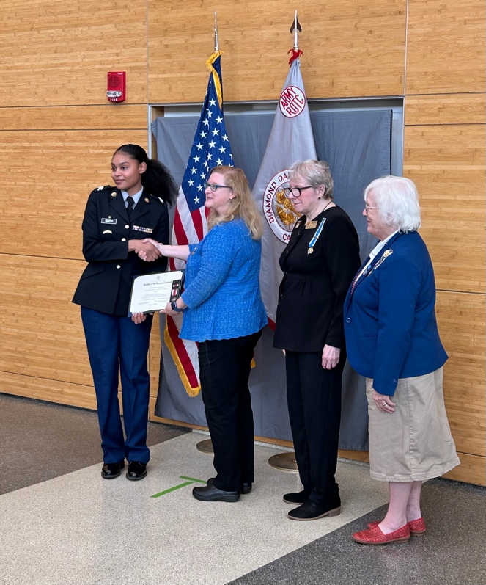
Cincinnati DAR Presentation
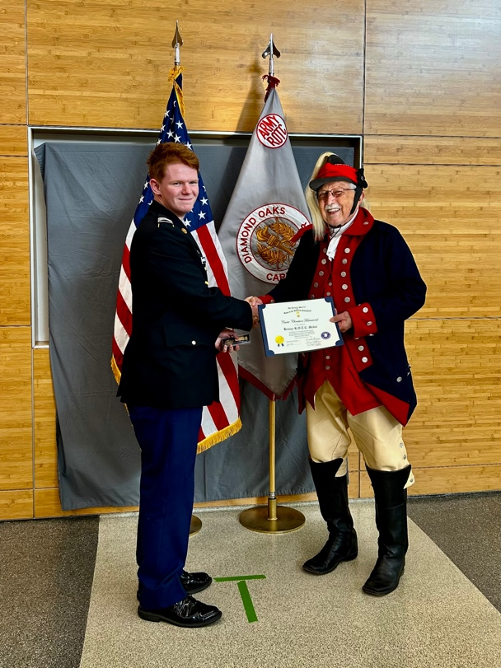
SAR Presentation to Cadet Hammond

