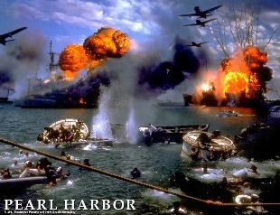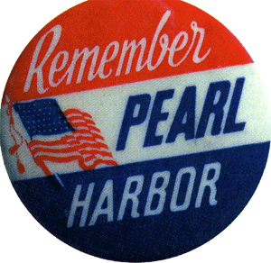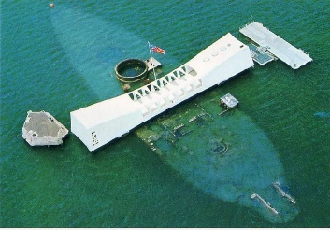

Chambers Hautman Budde
American Legion Post 534
4618 River Rd

Invites you to
Come and help us Honor & Remember those who lost their lives during the attack on Pearl Harbor
Sunday December 3, 2023
Doors open at 9:00 AM for coffee & Donuts
Follow by a Flag Retirement at 10:30
And The Ceremony at 11:55 on the Ohio River
we will be serving lunch after the Ceremony back at the Post

This is the 69th year Post 534 has held a Ceremony on the River

